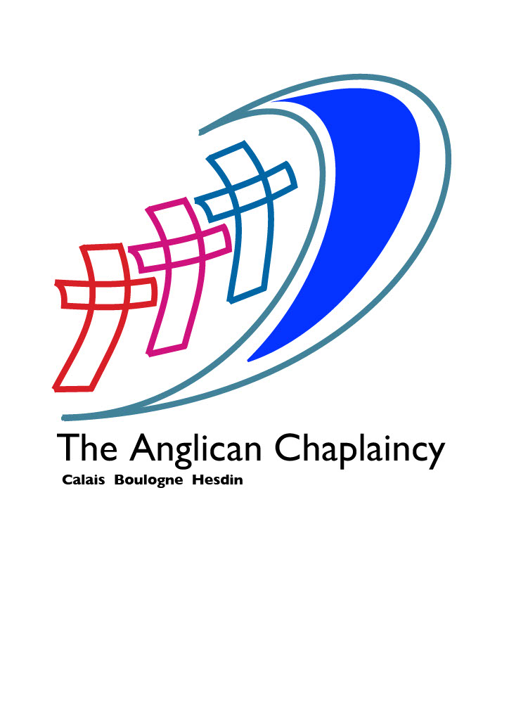
T he Anglican Church in Calais, Boulogne and Hesdin

Did you know that there is a lively, friendly and welcoming Anglican Christian community in the Pas-de Calais?

The Anglican Church seeks to minister to English speaking people in the Pas-de-Calais, by offering opportunities for worship, friendship
and fellowship.

Our three church communities are based in Boulogne, Calais and Hesdin. A service of Holy Communion is held every Sunday in one of the three centres (see below for details).

In addition there are lay-led praise services, prayer gatherings, Bible study and discipleship courses – some online, others in person. The church can offer baptisms, weddings and funerals in the Anglican tradition. We seek to care for those who are ill, housebound, lonely or bereaved, and hospital visiting is carried out when requested by the patient or patient’s family. We also share fully in ecumenical activities with other church denominations in the region.

Friendship is very important to us, and there is a programme of social events organised by all three church communities, where we welcome people of other faiths and nationalities. Events vary and include quizzes, garden parties, carol concerts, strawberry teas and coffee mornings.

If you would like more information about our chaplaincy, or our three church communities, please visit our website: anglicanspdc.com ; contact our chaplain (priest) The Revd. Teena Twelves: church.teena@gmail.com ; follow us on Facebook (Pas de Calais Anglican Church) – or why not come and see! Whether you are a resident, live here part of the time, are on holiday here, or just ‘passing through’ - we’d be delighted to welcome you.

Our next services: (visit our website or A Church Near You for future dates)
Calais (Salles Limoisin, rue Limoisin, Bleriot Plage) 1030 on Sun 14 June ;
Hesdin (Salle Paroissalle, rue de lArsenale, Hesdin) 1030 on Sun 21st June ; Boulogne (Chapelle des Carmelites, rue du Denacre, Boulogne) 1030 on Sun 28th June.

